Member Organisations
2 December 2020

What is a Member Organisation of RWSN?
RWSN is a network of individuals and organisations that are committed to improving water services for the rural poor everywhere in the world. Being a Member Organisation of RWSN is a commitment to sharing knowledge and good practices, and to uphold the statements set out in the RWSN Vision and 2011 Kampala Commitments.

Who can become a Member Organisation?
An organisation should fulfil the following criteria to become a Member Organisation:

- Support the aims of RWSN (agree to the RWSN Vision and Kampala Commitments 2011)
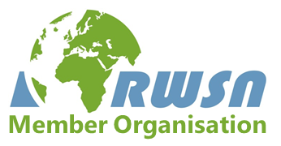
- Have a website
- Be willing to insert the "RWSN Member Organisation" logo on your website (if technically possible) and create a link back to the RWSN website
- Have at least three people working full time for your organisation
- Have been a registered entity for at least 2 years

If you do not meet these requirements then the individual membership is probably more suitable. Individuals can join by setting up a free account on dgroups: http://dgroups.org/rwsn

Benefits of membership
- Increased visibility and credibility with your listing on RWSN’s Member Organisation web page and the RWSN Member Organisation logo on your website;
- Preferential posting of items in the RWSN quarterly newsletter, reaching thousands of rural water professionals in several languages;
- Opportunity to collaborate on a larger platform with RWSN and other RWSN Member Organisations at Water and WASH events;
- Networking with other RWSN Member Organisations through exclusive face-to-face and online events.

Conditions and cost of membership
- RWSN does not set a mandatory membership fee; instead we invite each member organisation to contribute within their own capacity, as they consider what is possible each year. We have developed the table below to guide membership contributions based on organisation size.
- Membership contributions can be paid through our online payment form. Membership lasts for one calendar year and can be renewed or terminated by the Member Organisation, preferably during the first quarter of the year.

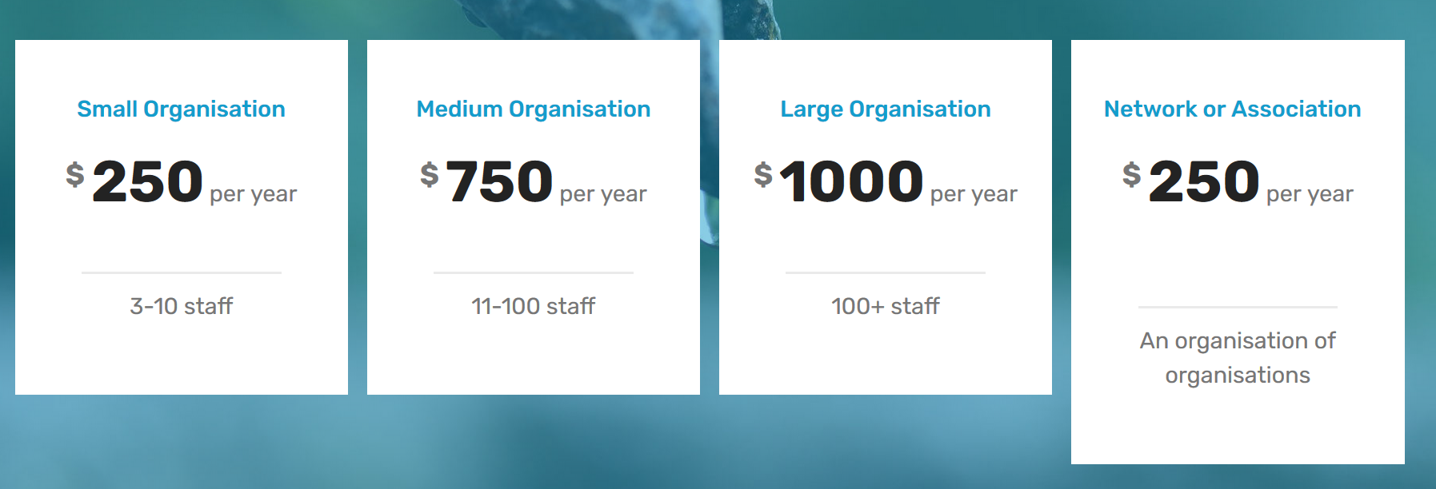

- The Executive Steering Committee of RWSN reserves the right to reject, suspend or terminate the membership of any organisation who they deem not to have behaved in a professional manner as set out in the Kampala Commitments 2011.

How to apply
Fill in this form and email to ruralwater@skat.ch
Organisation Name
Description
Country
State
City
Street
ZIP/Postal Code
Webpage
Contact email (to go on the RWSN website, e.g. info@...)
First Contact Person
E-Mail of contact 1:
Second contact person:
E-Mail of contact 2:
Phone:*
Logo | Please include an electronic version of your organisation’s logo at the highest resolution that you have. Your logo will appear on your Member Organisation page on the RWSN website and we would like to use it on general posters and flyers to indicate your membership and support for the network.  You can attach your logo separately or paste into this box.
Category: | □ Local NGO  □ International NGO  □ Private Sector  □ Education/Research  □ Government / State-owned organisation  □ Multilateral organisation / Development Partner  □ Network / Association  □ Other (please specify):
Founded in: | (year)
No. of employees  (please tick) | □3-10 ; □11-100 ; □100+ staff; □ More than 1,000
What countries are you active in?
How is your organisation active in the field of rural water supply?
What do you expect of being a Member Organisation?
How can you contribute to RWSN?
Commitment | □ We agree with the RWSN Vision and the 2011 Kampala Commitments

RWSN Vision
“RWSN’s vision is of a world in which all rural people have access to a sustainable and reliable water supply which can be effectively managed to provide sufficient, affordable and safe water within a reasonable distance of the home.”

The Kampala Commitments
The Kampala Rural Water Commitments Background/ Introduction The 6th International Forum of the Rural Water Supply Network was held in Kampala, 29th November – 2nd December 2011. The Forum was officially opened by Hon Maria Mutagamba, Minister of Water and Environment, Republic of Uganda. Opening addresses were also delivered by His Excellency the State Minister for Water Resources, Democratic Republic of Ethiopia and the Under Secretary, Ministry of Water Resources and Irrigation, Government of South Sudan. The participants in the forum numbered around 500 from nearly 50 countries, and were drawn from national and local Governments, academia, NGOs and CBOs, the private sector and development partners.

This statement of commitments should be read in conjunction with RWSN’s Strategy, Vision Paper, and the specific actions which have been articulated in the 30 sessions of the 6th Global Forum.

The following ten statements summarise our commitment to accelerating progress in inclusive and sustainable rural water supplies wherever those services are absent or under-performing.

Focusing on water users and water resources:
- We recognise the rights and the natural justice of all citizens to enjoy secure water services, regardless of location, lifestyle, gender, age, disability, ethnicity or income.
- We will do everything possible to ensure that the services we deliver are equitable and sustainable, providing lasting service with no time limits.
- We will take full account of all water users’ needs for close and unrestricted access, adequate quantity and acceptable quality of water, high levels of reliability, affordability, and a realistic burden of management responsibility.
- We recognise the multiple uses of water, and the multiple sources from which users take their water for domestic and livelihood purposes.

Focusing on ourselves as rural water professionals:
- We are committed to high quality of design, implementation (of both software activities and construction) and post-construction activities.
- We will continue to develop, promote, and adhere to specific standards and codes of good practice in rural water supply, and build close links to other development sectors which affect, or are affected by, this sub-sector.
- We will continue to enhance our own individual and organisational learning and professional development, with a special emphasis on south-south learning.
- We will advocate for: Increased and better-targeted finance for capital investments and for post-construction financing through local Governments to address the sustainability of rural water services.
- We will advocate for: Greater transparency and accountability in regard to progress in rural water provision and service performance.
- We will advocate for: Special efforts to raise the profile of rural water, including development of post-2015 targets and the possibility of an international year of rural water supply.

The Kampala Rural Water Commitments Endorsed and approved by the delegates to the 6th Global Forum of the Rural Water Supply Network, 1st December 2011.

